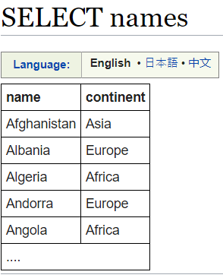

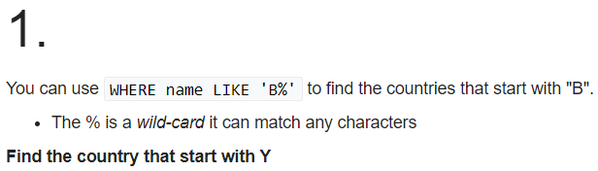

**Solution:-**

**SELECT name FROM world WHERE name LIKE 'Y%'**

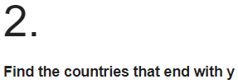

**Solution:-**

**SELECT name FROM world WHERE name LIKE '%y'**

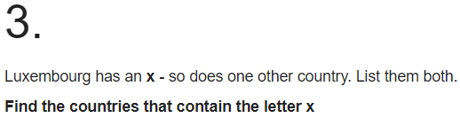

**Solution:-**

**SELECT name FROM world WHERE name LIKE '%x%'**

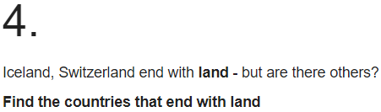

**Solution:-**

**SELECT name FROM world WHERE name LIKE '%land'**

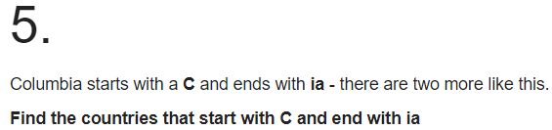

**Solution:-**

**SELECT name FROM world WHERE name LIKE 'C%' and name LIKE '%ia'**

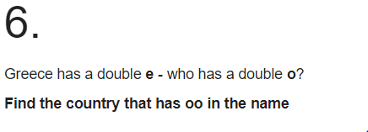

**Solution:-**

**SELECT name FROM world WHERE name LIKE '%oo%'**

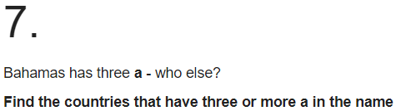

**Solution:-**

**SELECT name FROM world WHERE name LIKE '%a%a%a%'**

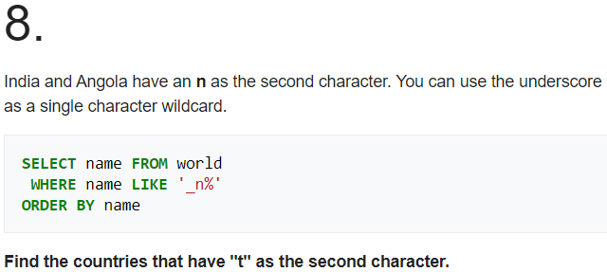

**Solution:-**

**SELECT name FROM world WHERE name LIKE '_t%' ORDER BY name**

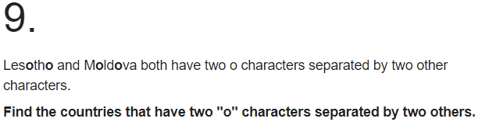

**Solution:-**

**SELECT name FROM world WHERE name LIKE '%o__o%'**

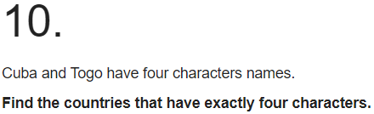

**Solution:-**

**SELECT name FROM world WHERE name LIKE '____'**